**Ideation Phase**

**Brainstorm & Idea Prioritization Template**

|  |  |
| --- | --- |
| Date | 20 June 2025 |
| Team ID | LTVIP2025TMID28652 |
| Project Name | Educational Organisation Using ServiceNow |
| Maximum Marks | 4 Marks |

**Brainstorm & Idea Prioritization:**

The **Brainstorm & Idea Prioritization**  is a structured guide used by teams to generate creative ideas and identify the most effective ones. It encourages open thinking, where all ideas—no matter how unusual—are welcomed. The process involves gathering the team, selecting a problem to solve, listing all ideas, grouping similar ones, and finally evaluating them based on impact and feasibility. This helps teams focus on the best solutions while promoting collaboration and innovation. The template is ideal for both in-person and remote brainstorming sessions.

Reference: <https://www.mural.co/templates/brainstorm-and-idea-prioritization>

**Step-1: Team Gathering, Collaboration and Select the Problem Statement**

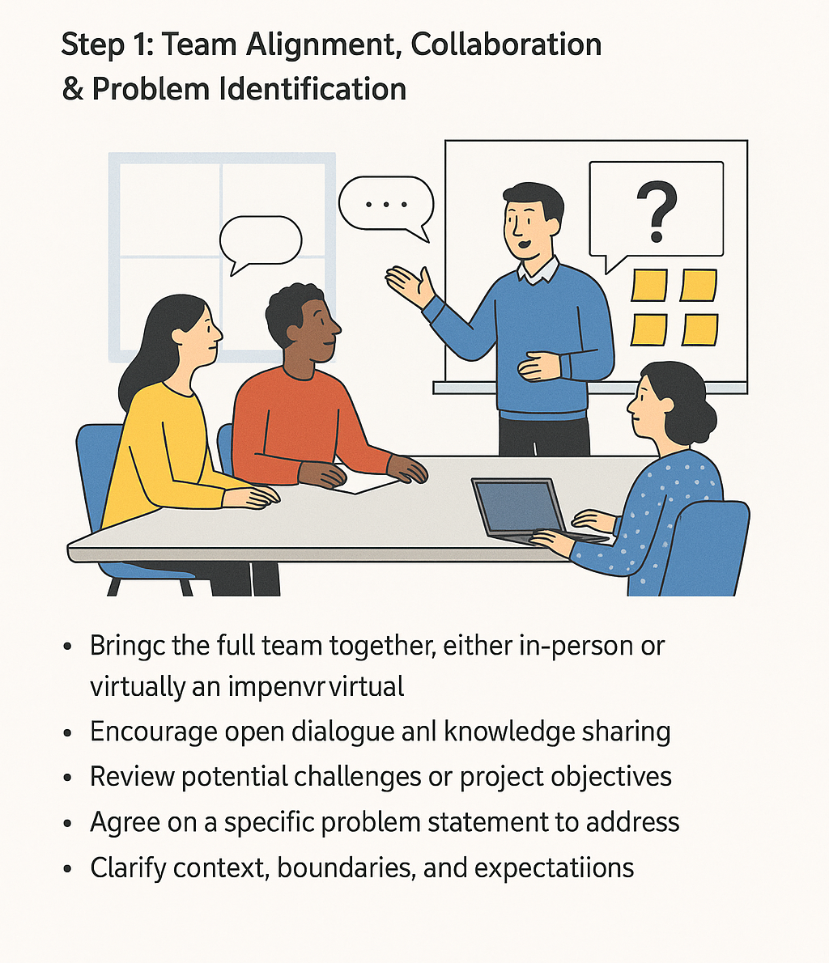

**Step-2: Brainstorm, Idea Listing and Grouping**

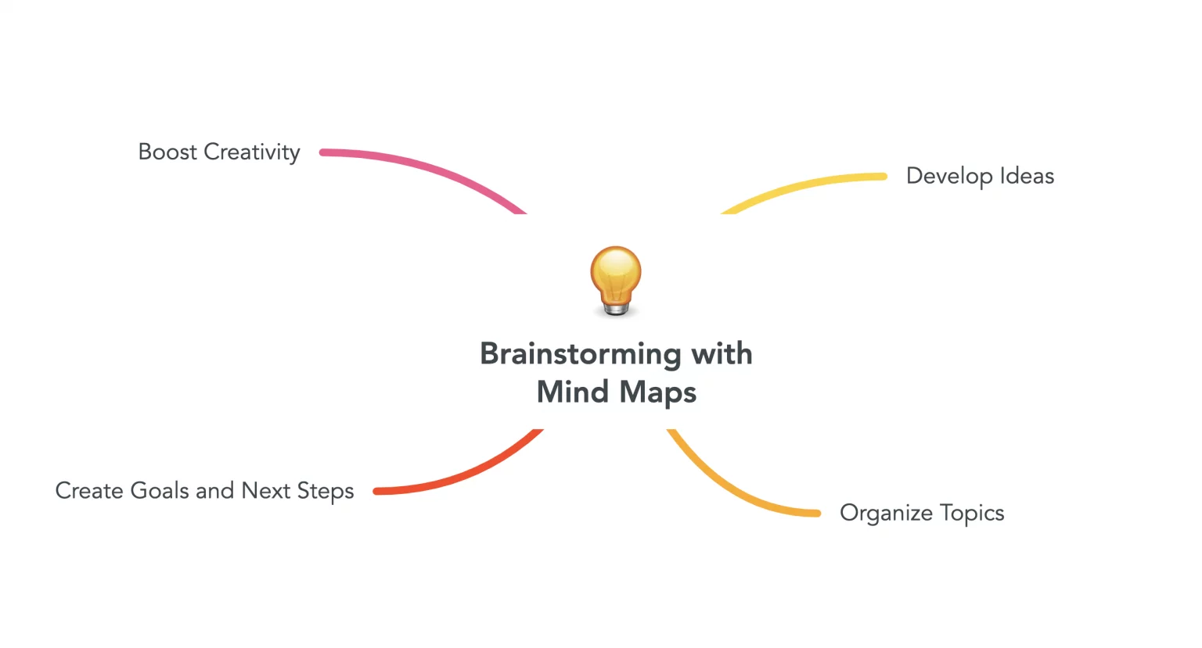

**Step-3: Idea Prioritization**

